Assigement No 1 OF RDS
1 War file is deploy Slave-1 by Jenkins plieline
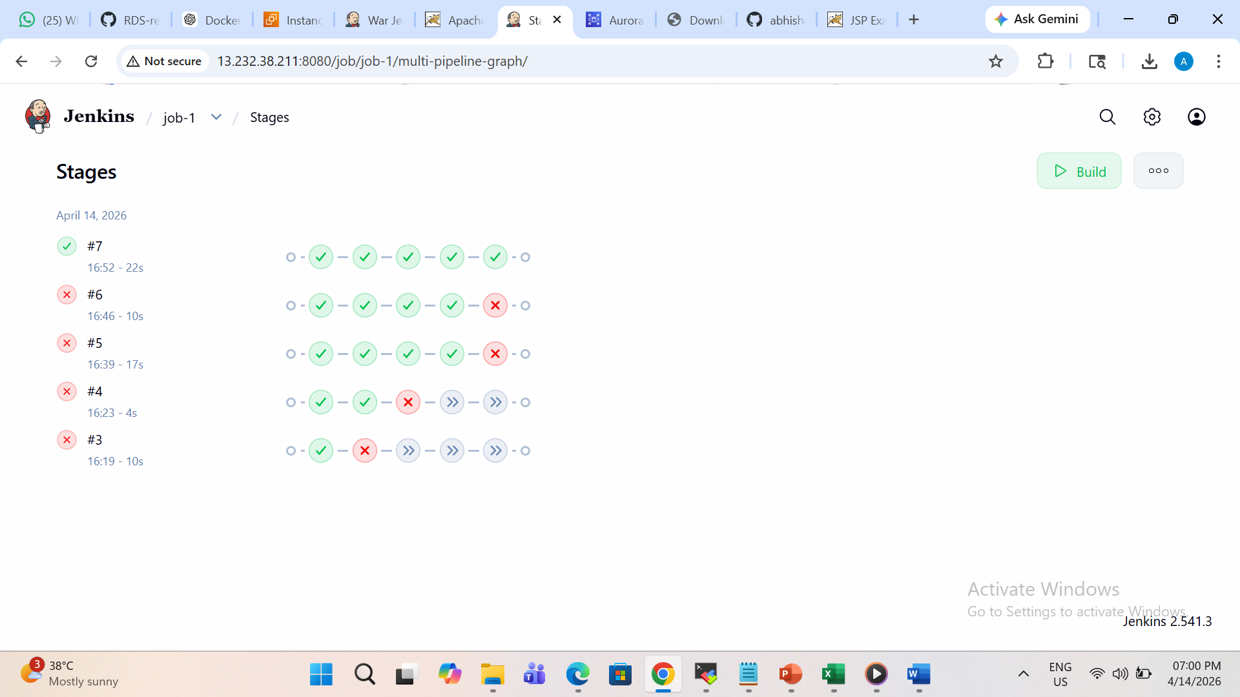
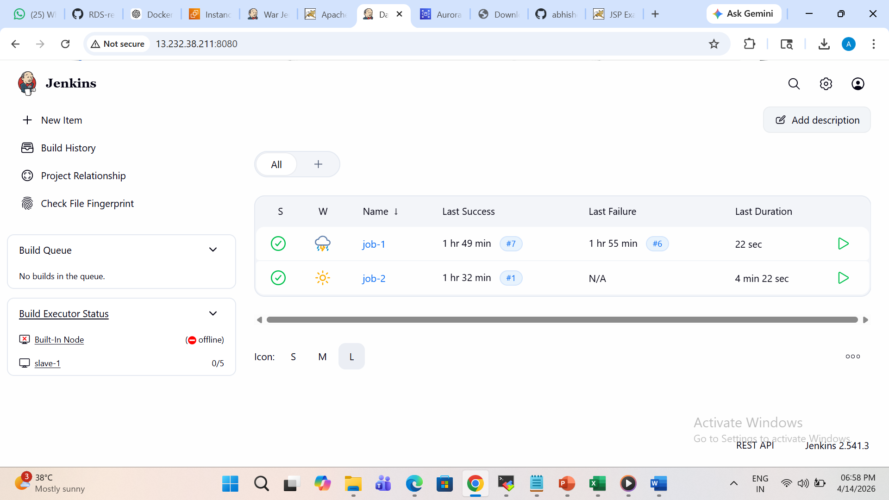

2 Building LoginWebApp in Jenkins Machine
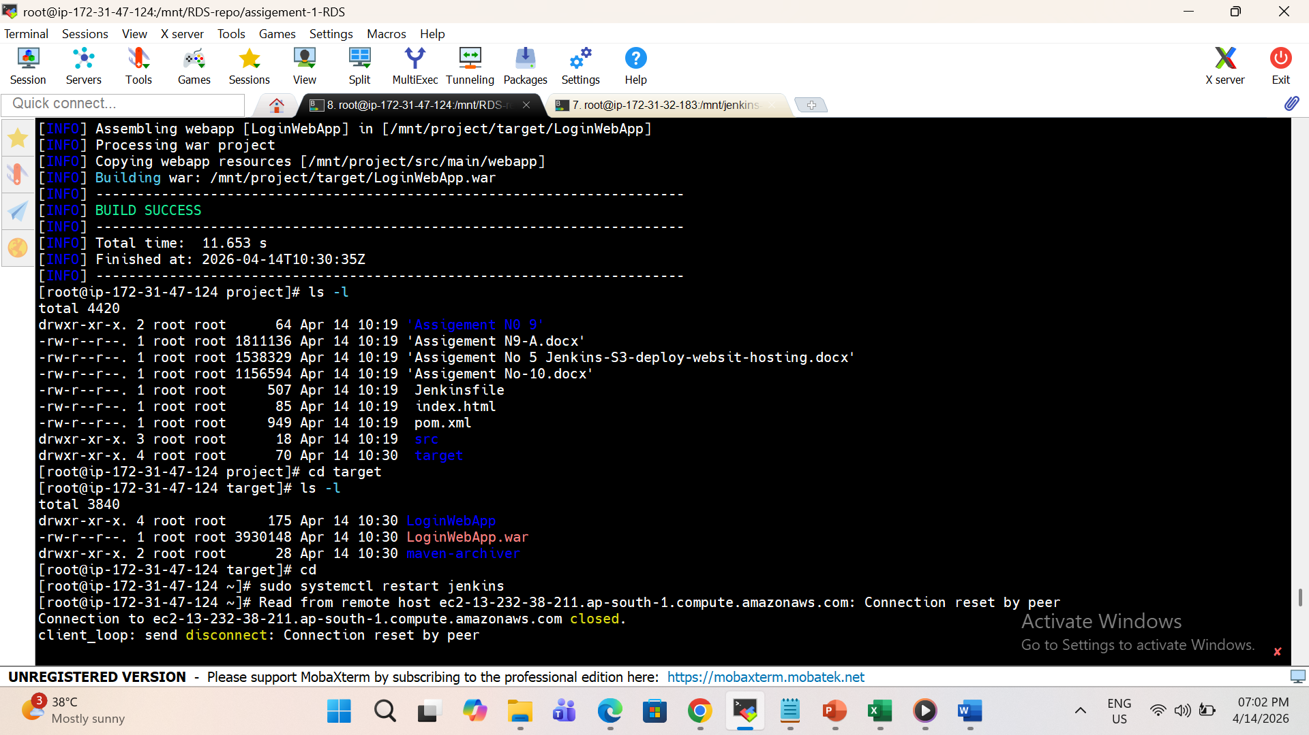
3 Deployin War with help of Shell scripit
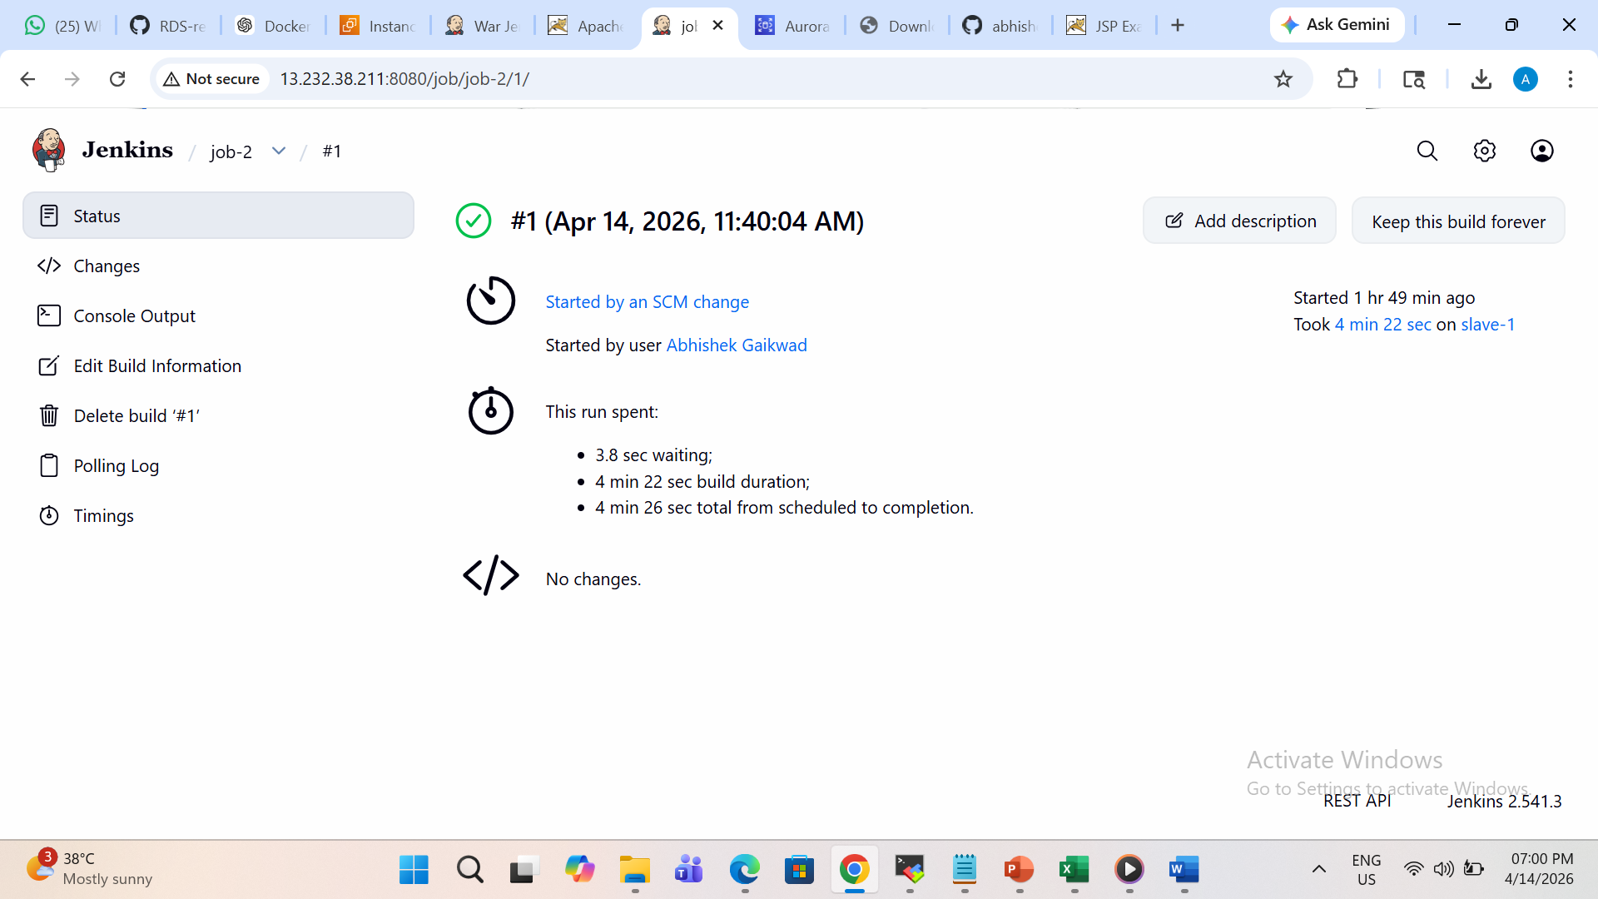

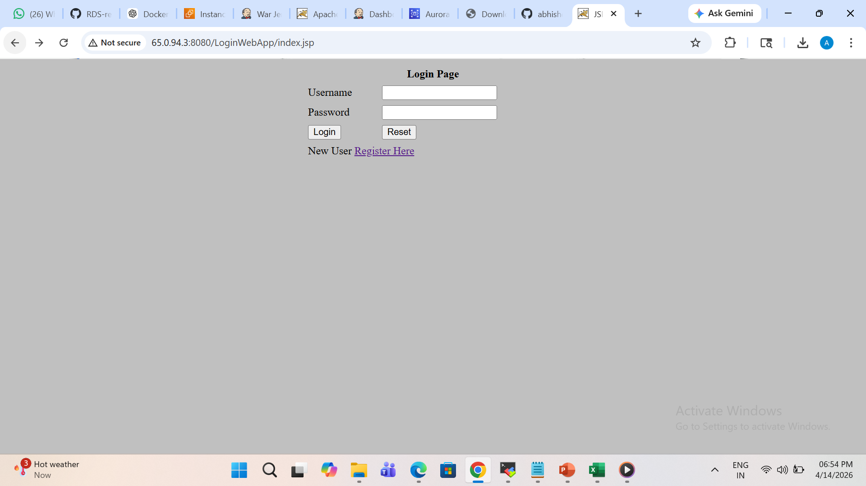
Shell Scripit
#!/bin/bash

echo "===== START AUTO DEPLOY ====="

WAR_FILE=target/LoginWebApp.war
UPDATED_WAR=LoginWebApp-updated.war
TEMP_DIR=temp_war
SERVER_IP=3.110.115.64
TOMCAT_PATH=/mnt/server/apache-tomcat-10.1.54/webapps
# Clean old temp
rm -rf $TEMP_DIR
mkdir $TEMP_DIR
cd $TEMP_DIR || exit
# Extract WAR
echo "Extracting WAR..."
jar -xvf ../$WAR_FILE > /dev/null

# Update DB config
echo "Updating DB config..."
FILE=$(find . -name "userRegistration.jsp")
sed -i "s|localhost:3306|database-1.cng880gi2duy.ap-south-1.rds.amazonaws.com|g" $FILE
sed -i "s|root|$DB_USER|g" $FILE
sed -i "s|1234|$DB_PASS|g" $FILE
# Repack WAR
echo "Repacking WAR..."
jar -cvf ../$UPDATED_WAR * > /dev/null
cd ..
rm -rf $TEMP_DIR
# 🚀 DEPLOY TO TOMCAT
echo "Deploying to server..."
scp -o StrictHostKeyChecking=no $UPDATED_WAR ec2-user@$SERVER_IP:/home/ec2-user/
ssh -o StrictHostKeyChecking=no ec2-user@$SERVER_IP << EOF
sudo mv /home/ec2-user/$UPDATED_WAR $TOMCAT_PATH/LoginWebApp.war
sudo systemctl restart tomcat

